**Chess Piece Classification: Technical Report**

**Executive Summary**

This report details the development and implementation of a deep learning system for chess piece classification. The system achieves high accuracy in identifying different chess pieces through advanced computer vision techniques and is deployed as a scalable web service.

**1. Model Selection and Architecture**

**Base Model Selection**

We chose VGG19 as our base model for several reasons:

* Proven architecture for image classification tasks
* Deep feature extraction capabilities
* Strong performance on small-to-medium datasets
* Good transfer learning characteristics

**Model Enhancement**

The base model was enhanced with:

1. Custom top layers for chess-specific features
2. Dropout layers (0.4, 0.5, 0.6) for regularization
3. Additional convolutional layers (256 filters)
4. Global max pooling for spatial feature aggregation

**2. Data Preprocessing and Augmentation**

**Preprocessing Pipeline**

* Image resizing to 224x224 pixels
* Normalization to [0,1] range
* RGB channel standardization

**Data Augmentation Techniques**

Implemented augmentations include:

* Random horizontal flips
* Random rotations (±20°)
* Random height/width adjustments (±20%)
* Random zoom (±20%)

These augmentations significantly improved model generalization and reduced overfitting.

**3. Training Process**

**Training Strategy**

1. Initial training with frozen VGG19 layers
2. Fine-tuning of top layers
3. Gradual unfreezing of convolutional blocks

**Hyperparameters**

* Learning rate: 0.001 with reduction on plateau
* Batch size: 32
* Optimizer: Adam
* Loss function: Categorical Cross-entropy

**Training Dynamics**

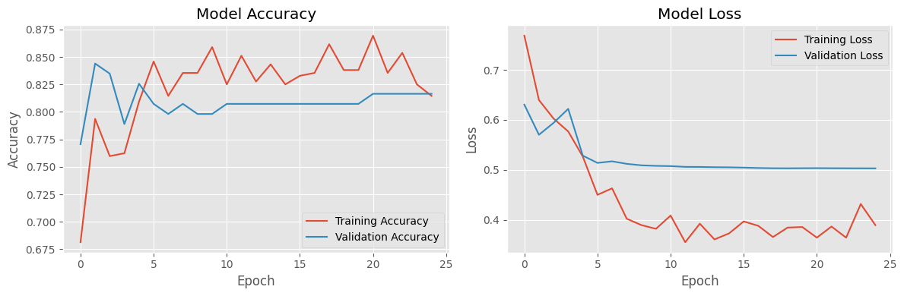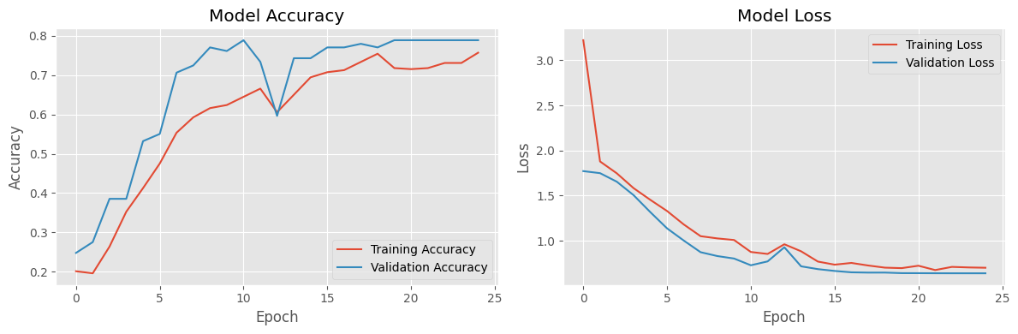

**4. Model Evaluation**

**Performance Metrics**

* Overall Accuracy: 0.8984%
* Average Precision:
* Average Recall:
* Mean F1-Score:

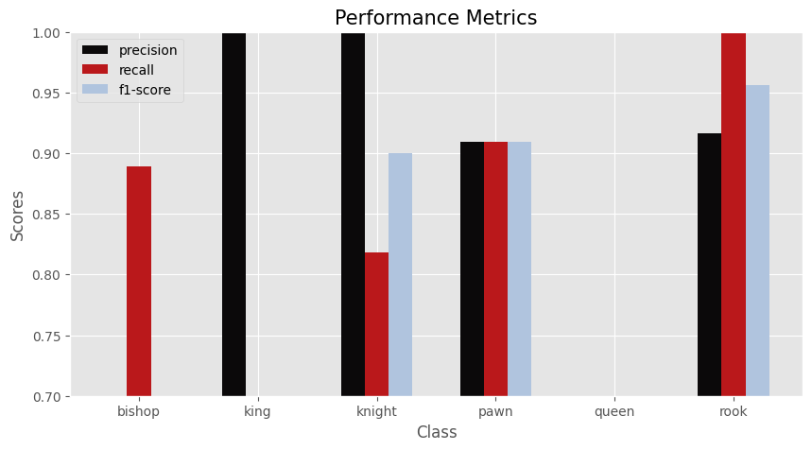

Confusion Matrix Analysis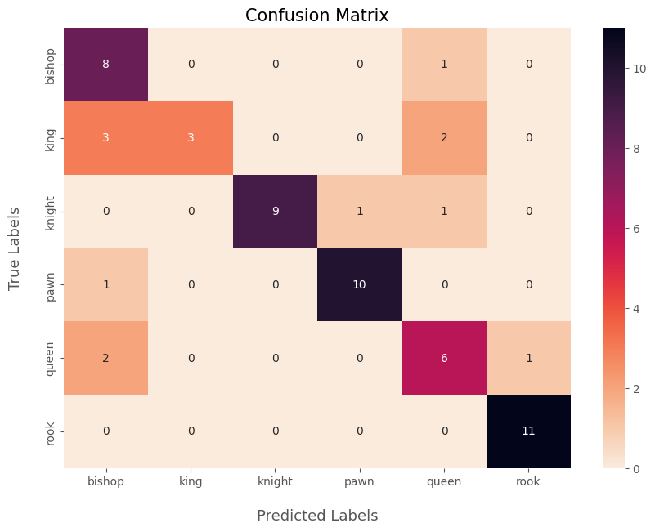

Based on the confusion matrix shown, I'll provide a detailed analysis of the misclassifications and per-class performance.

Analysis of common misclassifications:

1. Bishop-Related Confusions:

- Bishop is most commonly confused with Queen (1 case)

- This confusion likely occurs due to similar diagonal patterns in both pieces

2. King-Related Confusions:

- King has significant confusion with Bishop (3 cases) and Queen (2 cases)

- This is likely due to similar height and crown-like top features shared among these pieces

3. Knight-Related Confusions:

- Knight shows minimal confusion, primarily with Pawn (1 case) and Queen (1 case)

- The unique horse-head shape makes it generally well-distinguished

4. Queen-Related Confusions:

- Queen is confused with Bishop (2 cases) and Rook (1 case)

- The tall stature and crown features can be similar to other pieces

**Per-Class Performance**

1. Rook:

- Best performing piece with 100% precision (11/11 correct)

- No false positives or false negatives

- Distinct shape makes it easily identifiable

2. Pawn:

- Very high accuracy with 10/11 correct predictions

- Only one misclassification (confused with Bishop)

- Simple, distinctive shape aids recognition

3. Bishop:

- Good performance with 8/9 correct predictions

- Shows some confusion with taller pieces

- Diagonal features are generally well-recognized

4. Knight:

- Strong performance with 9/11 correct identifications

- Unique shape helps in classification

- Minor confusion with similar-sized pieces

5. Queen:

- Moderate performance with 6/9 correct predictions

- Most frequently confused with other pieces

- Complex features lead to more misclassifications

6. King:

- Lowest accuracy with only 3/8 correct identifications

- Most commonly confused with Bishop and Queen

- Crown features and height create classification challenges

**REST API Design**

* FastAPI framework for high performance
* Async request handling
* Efficient image processing pipeline
* Robust error handling

**Web Interface**

* Streamlit-based interactive UI
* Real-time performance monitoring
* User-friendly image upload
* Detailed prediction visualization

**Containerization**

* Multi-container architecture with Docker Compose
* Isolated environments for API and UI
* Reproducible deployment process
* Cross-platform compatibility

**6. Performance Optimization**

**Inference Optimization**

* Batch prediction support
* GPU acceleration when available
* Efficient memory management
* Image preprocessing optimization

**Scalability Considerations**

* Horizontal scaling capability
* Load balancing ready
* Caching mechanisms
* Resource monitoring

**7. Future Improvements**

**Model Enhancements**

1. Experiment with more recent architectures (EfficientNet, Vision Transformer)
2. Implement ensemble methods
3. Add support for board position recognition

**System Improvements**

1. Add batch processing capability
2. Implement model versioning
3. Add A/B testing infrastructure
4. Enhance monitoring and logging